Year 12 ATAR Biology

Unit 4: Disease Test

Section One: Multiple Choice (20 marks)

Mark your answers on the answer grid provided.

_____________________________________________________________________________________

The graph below shows the characteristic shape for the population growth of a pure, sealed culture of bacteria. Use this information to answer questions 1 and 2.

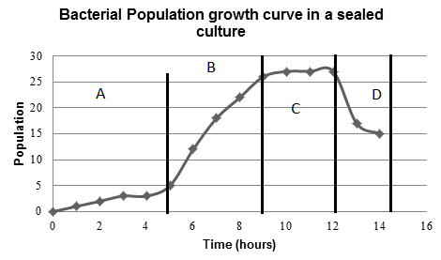

1. Which phase of the graph represents the stage of population growth where death rate is equal to the rate of cell division?
2. A
3. B
4. C
5. D

2. Which phase of the graph represents the stage where there is limited competition between the bacteria in the culture?

1. A
2. B
3. C
4. D
5. Disease that can be transmitted between animals and humans is termed:

(a) a fomite.

(b) pandemic.

(c) epizootic.

(d) zoonotic.

1. Vectors are important in the spread of many diseases. It is reasonable to suggest that:
2. vectors are the organisms that can infect and individual and cause disease in the host.
3. vectors are involved in the transmission of viral diseases only.
4. diseases associated with a particular vector are usually restricted to the geographical area that supports that vector.
5. insects are the only organisms that can act as vectors.
6. Eight sick animals were found to be suffering from the same symptoms. Blood tests showed that they were infected with the same type of bacterium. Which of the following strategies would be the best to determine if this particular type of bacterium is the cause of the disease?

a) Find other animals with the same symptoms and attempt to isolate the same type of bacterium from their blood.

b) Inject blood from animals with the symptoms into suitable host individuals. If they develop the same symptoms, this proves that this type of bacterium caused the disease.

c) Use bacteria cultured from the blood of the animals with these symptoms to infect suitable host individuals. If they develop the disease, attempt to isolate the same type of bacterium from their blood.

d) Treat all eight animals with an antibiotic known to kill this type of bacterium. They will recover if this type of bacterium is the cause of the disease.

1. Overseas equestrian competitors brought their horses to Australia for the Sydney 2000 Olympic Games. Why were the horses quarantined for a period of time before the Olympic Games began?

a) To acclimatise them to Australian weather conditions.

b) To make sure that no horse diseases spread to the spectators.

c) To make sure that the horses did not contract Australian diseases.

d) To make sure that the horses did not have an infectious disease.

Questions 7 and 8 refer to the diagram below.

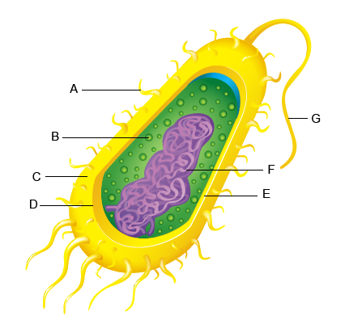

<http://www.proprofs.com/quiz-school/story.php?title=bacteria-quiz>

1. [Which best classifies the cell shown?](http://www.helpteaching.com/questions/303832/which-best-classifies-the-cell-shown)

a) plant

b) animal

c) bacterial

d) protozoan

1. [Which structure is represented by the letter B on the bacterial cell diagram?](http://www.helpteaching.com/questions/303835/which-structure-is-represented-by-the-letter-a-on-the-bacter)

a) pilus

b) nucleoid

c) ribosome

d) flagellum

1. A typical virus consists of

a) a protein coat and a cytoplasm core

b) a carbohydrate coat and a nucleic acid core

c) RNA or DNA in a protein coat

d) a polysaccharide coat and a nucleic acid core

10. Most parasites do not kill their hosts because, in order to live, they require their hosts to continue living too. However, parasitic fungi can kill their hosts and continue to thrive. What is the likely reason for this?

a) Fungi can always easily find a new host.

b) Fungi can continue to absorb energy by decomposing the dead organic material.

c) Fungi can make their own energy until a new host is available.

d) Fungi can stop using energy until a new host is available.

11. Bacteria adapt more quickly than elephants to environmental changes. Which best explains the difference?

a) Bacteria reproduce more quickly, speeding up the process of natural selection.

b) Bacteria move more quickly, allowing them to migrate easier.

c) Elephants have more genes, so they mutate slower.

d) Elephants are not affected by antibiotics.

12. Which of the following statements can be used to describe a pathogen?

a) They are all viral.

b) They are all infectious.

c) They are all microscopic.

d) They are all macro-parasites.

13. Recently, hospitals and medical practitioners have warned the community about the spread of severe acute respiratory syndrome (SARS). People were experiencing:

* high temperatures
* body aches
* pains similar to that of the flu.

How would you classify these descriptions?

a) Controls

b) Symptoms

c) Warnings

d) Methods of transmission

14. Which of the following is an example of quarantine used to control the spread of disease across regions of Australia?

a) Killing weeds in infested forests using herbicides and direct removal

b) Sterilisation of all food products that come from overseas

c) Sterilisation of all food products before packaging

d) Removal of fruit from cars travelling interstate

15. During the last 50 years, over-use of prescription drugs has led to the emergence of resistant strains of particular pathogenic bacteria. Why is this a problem?

a) A single prescription drug can no longer kill all strains of a pathogen.

b) Many diseases will lose their ability to cause disease.

c) Resistant pathogens will cause new types of diseases.

d) Prescription drugs will cause the release of toxins by pathogens.

16. Students performed an investigation to compare the effectiveness of two water treatments for purifying pond water. Three samples of pond water, *A*, *B* and *C,* were collected and each used to inoculate an agar plate. The plates were incubated at 25°C and examined three days later. The number of visible bacterial colonies on each plate was counted and the results tabulated.

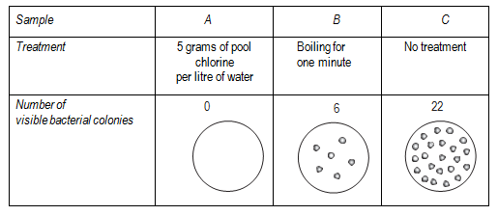

What is the dependent variable in this investigation?

a) The use of a control sample.

b) The number of visible bacterial colonies.

c) The use of sterile agar plates for each sample.

d) Treating the water by boiling or adding pool chlorine.

17. Fomites are

1. animals that carry disease that can spread to humans.
2. Living vectors that carry disease.
3. Drugs that can be used to treat malaria
4. Non-living objects that act as vehicles for infectious diseases.

18. Which of the following differentiates correctly between antibiotics and vaccines?

(a) Antibiotics provide long lasting immunity due to the production of memory cells, while vaccines only provide short term immunity.

(b) Antibiotics treat for an invading pathogen, while many vaccines involve the introduction of an inactivated pathogen into the bloodstream.

(c) Antibiotics provide artificial, active immunity, while vaccines provide artificial, passive immunity.

(d) Antibiotics are often injected into the bloodstream, while vaccines are normally ingested in pill form.

19. An intermediate host which carries a pathogen that causes a disease from one organism to another is called

(a) an antibiotic

(b) a zoosporangium

(c) an endemic species

(d) a vector

20. Which of the following helps prevent the entry of pathogens into humans?

(a) Cilia

(b) Antigens

(c) B lymphocytes

(d) Inflammation response

Year 12 ATAR Biology

Unit 4: Disease Test

NAME _________________________________________ Total _____________/ 65

**Section One: Multiple Choice (20 marks)**

Mark your answers on the answer grid below.

|  |  |  |  |  |  |  |  |  |  |  |
| --- | --- | --- | --- | --- | --- | --- | --- | --- | --- | --- |
| **Question** |  | | | |  | **Question** |  | | | |
| **1** | **A** | **B** | **C** | **D** |  | **11** | **A** | **B** | **C** | **D** |
| **2** | **A** | **B** | **C** | **D** |  | **12** | **A** | **B** | **C** | **D** |
| **3** | **A** | **B** | **C** | **D** |  | **13** | **A** | **B** | **C** | **D** |
| **4** | **A** | **B** | **C** | **D** |  | **14** | **A** | **B** | **C** | **D** |
| **5** | **A** | **B** | **C** | **D** |  | **15** | **A** | **B** | **C** | **D** |
| **6** | **A** | **B** | **C** | **D** |  | **16** | **A** | **B** | **C** | **D** |
| **7** | **A** | **B** | **C** | **D** |  | **17** | **A** | **B** | **C** | **D** |
| **8** | **A** | **B** | **C** | **D** |  | **18** | **A** | **B** | **C** | **D** |
| **9** | **A** | **B** | **C** | **D** |  | **19** | **A** | **B** | **C** | **D** |
| **10** | **A** | **B** | **C** | **D** |  | **20** | **A** | **B** | **C** | **D** |

Section Two: Short answer (45 marks)

Answer all questions in this section in the space provided.

_____________________________________________________________________________________

Question 21 (4 marks)

Compare and contrast the following terms:

1. Pathogenicity and virulence. (2 marks)

* Pathogenicity refers to the ability / capacity of an organism to cause disease (ie, harm the host)

.eg. Some people are naturally immune to certain diseases

* Whereas virulence refers to the degree / severity / intensity of a pathogen to affect its host.

e.g. rabies kills all its hosts but a cold rarely kills

1. Epidemic and Pandemic. (2 marks)

* Epidemic is a widespread occurrence of an infectious disease in a community at a particular time NOT whole country
* Pandemic is prevalence of a disease over a whole country or the world

Question 22 (6 marks)

Whooping cough is a disease that affects some infants. Doctors collected data relating to whooping cough between 1965 and 1996. They collected data for the number of cases of whooping cough reported and the percentage of infants vaccinated against whooping cough.

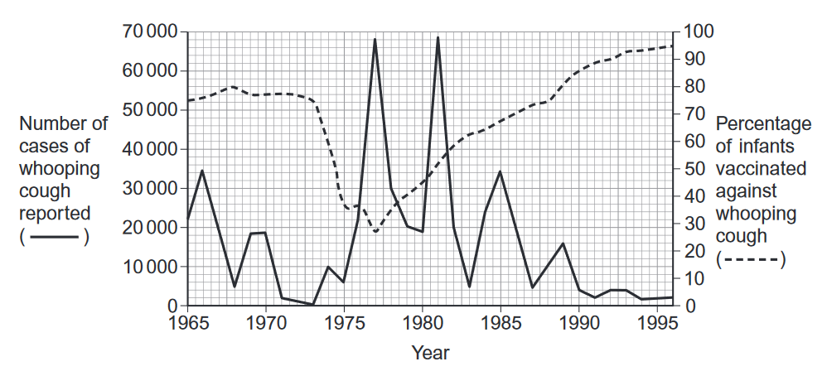

1. Suggest two reasons why the percentage of infants vaccinated decreased between 1973 and 1975.

(2 marks)

* Decrease linked to fewer cases of whooping cough
* Risk/fear of side effects
* Insufficient vaccine available/ too expensive to distribute/ produce (too expensive not full mark, must be qualified

1. Between 1980 and 1990 there were three peaks in the number of reported cases of whooping cough. After 1981 the number of cases of whooping cough in each peak decreased. Use the information in the graph to suggest reasons why. (2 marks)

* Vaccine rate increases – must use graph data-(1) from 30% to 85%
* Fewer people to spread the disease
* More people immune
* Greater herd effect

1. The percentage of the population vaccinated does not need to be 100% to be effective in preventing the spread of the disease. Explain why. (2 marks)

* More people are immune
* Fewer people carry the pathogen
* So susceptible/unvaccinated people less likely to contact infected people.
* Called the herd effect because they get protection from the herd

Question 23 (24 marks)

Malaria and Ross River are both diseases described as being mosquito borne diseases.

1. List the symptoms and treatments for Malaria and Ross River virus in the table below. (6 marks)

|  |  |  |
| --- | --- | --- |
|  | Malaria | Ross River |
| Symptoms | * high fever/ temperature * profuse sweating/ chills * headache. * nausea. * vomiting. * diarrhea. * anemia.   2 symptoms for 1 mark (first two) | * sore muscles. * aching tendons. * skin rashes (although these tend to be more common to BFV disease) * fever. * Tiredness/ lethargy   2 symptoms for 1 mark ( first two) |
| Treatment | * chloroquine. * atovaquone-proguanil (Malarone®) * artemether-lumefantrine (Coartem®) * mefloquine (Lariam®) * quinine/ quinidine * blood transfusion   (1 treatment-first one) | * Treatment for symptoms such as anti-inflammatory drugs * Paracetomol * No cure   (1 treatment – first one) |

1. Use a flow diagram to describe to lifecycle of Malaria. (5 marks)

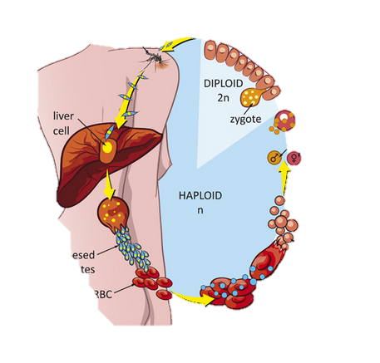

1.mosquito bites human

Sporozoites to liver

makes merozoites asexually

2.merozoites makes toxins

Destroy RBC

makes gametocytes

3 male and female gametocytes

In blood of human

4 Mosquito ingests gametocytes with

Blood. Travels to stomach

Fertilisation occurs here making new

Sporozoites sexually

5 Sporozoites travel to salivary glands

of mosquito to infect new human

deduct I mark if not a flowchart ( cycle)

1. **Describe and explain** two ways a person can prevent themselves contracting Malaria. (4 marks)

* DET repellents to deter or repel mosquitoes NOT DDT
* Cover up with loose clothing so they cannot get to skin
* Use mosquito nets over bed at night to prevent bites
* Avoid being near known places/ times where mosquitoes are present
* Sleeping with a dog or pig helps as the mosquito prefers animal blood!
* Taking anti - malarial drugs before entering a known mosquito area.

1. Through the Mozzie Wise school education program run by Sercul, school children are educated on the life cycle of the mosquito and how the environment can be managed to reduce the prevalence of mosquitos in urban area. Describe and explain two strategies that can be **employed in the** **environment** to reduce the population of particular mosquito species which transmit disease.

(2 marks)

* Insecticide spraying to kill mosquitos -> reduce population of mosquitos
* Tip out standing water in buckets etc after rain fall to prevent laying of eggs/larval stage
* Increase populations of fish which eat the larve (e.g pigmy perch or gambusia
* Increase frog habitats / bat boxes to encourage them to stay and eat mosquitoes)

Must be qualified statements explain how they interrupt the life cycle. Must be environmentally OK

1. The distribution of Malaria around the world is influenced by many factors including climate change. Describe why and how climate change could impact on the global distribution of the disease.

(3 marks)

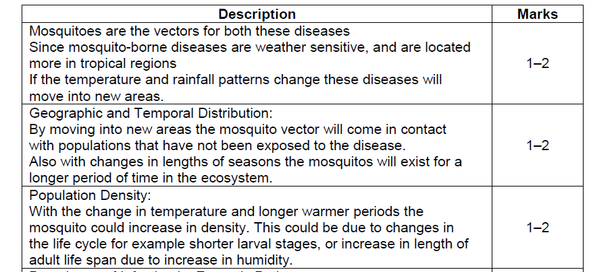

**Question 24 (12 marks)**

1. Identify the microorganism that causes Jarrah Dieback and describe the characteristics of the disease. (4 marks)

* Phytophthora cinnamomi
* Protist,
* Trees/plants die because the root systems are affected
* Cannot take up water or nutrients

1. Describe two impacts of Dieback on the natural ecosystem. (2 marks)

* More than 40 per cent of Western Australian native plants are susceptible to the disease, particularly those in state's south-west.
* The area of land infected in Western Australia by Phytophthora dieback is equivalent to 500 times the size of Rottnest Island or over one million hectares.
* Twenty per cent of the state's jarrah forest and up to 80% of the [Stirling Range National Park](http://parks.dpaw.wa.gov.au/park/stirling-range) infected.
* Lost of habitat and food sources

1. Describe and explain three strategies than can be employed to limit the spread of Dieback. (6 marks)

ANY 3 qualified statements

* Quarantine or destroy all infected plants/soil
* Screening of all Jarrah trees to be replanted
* Covers for shoes
* Washing stations to prevent human spread
* Clean vehicles especially tyres
* Remain out of infected areas up to 3 days after rain
* Spraying of fungicides on infected soils
* Use impermeable materials for roads to prevent run off
* Seasonal and permanent road closures to infected area
* Aeration of soil, limits growth of the pathogen
* Any other reasonable control mreasure
* Statements must be qualified

END OF TEST